Exercise 6:

Draw a Use case diagram to model for a quiz system. A user can request a quiz for the

system. The system picks a set of questions from its database, and composes them

together to make a quiz. It rates the user’s answers and gives hints if the user requests

it. In addition to users, we also have helpers who provide questions and hints. And also, administrators who must certify questions to make sure they are not too trivial, and that they are correct

Aim:

To design a UML Use Case Diagram for a Quiz System that models the interactions between users, helpers, and administrators in managing and taking quizzes.

Procedure:

Step 1: Identify Key Actors

User

Requests a quiz

Answers quiz questions

Requests hints

Receives ratings

Helper

Provides questions

Provides hints

Administrator

Certifies questions (ensures correctness and difficulty level)

Quiz System

Selects questions from the database

Composes quizzes

Evaluates user answers

Rates users

Step 2: Define Use Cases for Each Actor

User

Request Quiz

Answer Questions

Request Hint

Receive Rating

Helper

Provide Questions

Provide Hints

Administrator

Certify Questions

Quiz System (automated processes)

Select Questions

Compose Quiz

Evaluate Answers

Rate User

Step 3: Draw the UML Use Case Diagram

In the Use Case Diagram, actors interact with use cases as follows:

User interacts with:

"Request Quiz"

"Answer Questions"

"Request Hint"

"Receive Rating"

Helper interacts with:

"Provide Questions"

"Provide Hints"

Administrator interacts with:

"Certify Questions"

Quiz System performs:

"Select Questions"

"Compose Quiz"

"Evaluate Answers"

"Rate User"

OUTPUT:

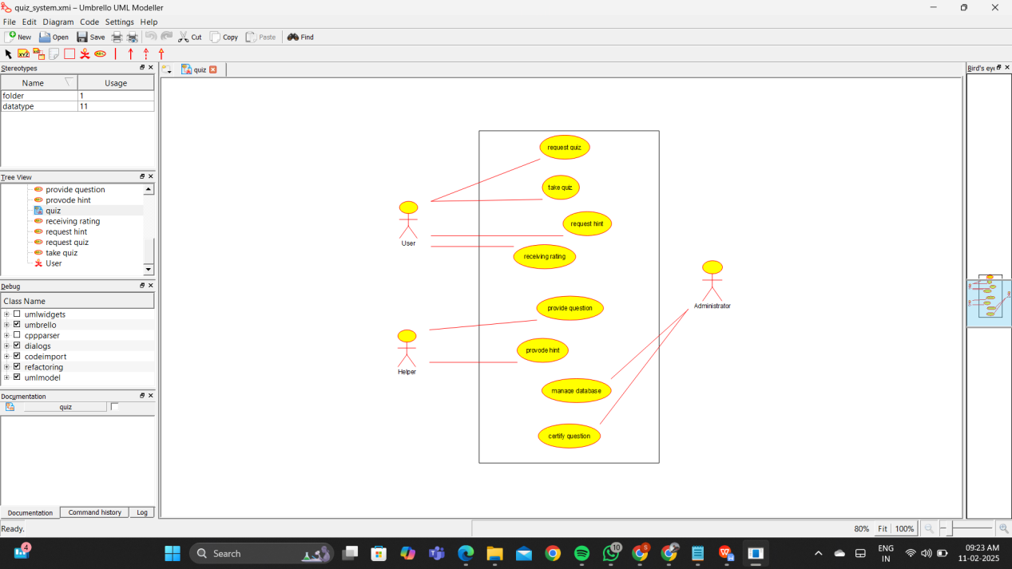

Result:

Thus the UML diagram has been implemented successfully.